Self-check 4.1 questions

1. Results are:
2. The String “Jane” gets pushed into the stack. [“Jane”]
3. Top equals the String “Jane” that is peeked from the stack. [“Jane”]
4. The String Joseph gets pushed into the stack. [“Jane”, “Joseph”]
5. NextTop equals the String Joseph and gets removed from or popped out of the stack. [“Jane”] popped -> “Joseph”
6. The top of names gets printed and then it gets popped out of the stack until it is emptied out by the loop. The loop would print the top of the stack and all of the stack until it is empty.

Example Output:

Joseph

Jane

Example Stack Result: []

1. If peek was used into of pop in question 2, the top of names would stay in the stack and get printed infinitely by the loop’s condition will always be true since nothing is removed from the stack by the usage of peek. Therefore, it will not be empty.

Example Output:

Joseph

Joseph

Joseph

…

Example Stack Result: [Jane, Joseph]

Self-check questions 4.3 1 & 3

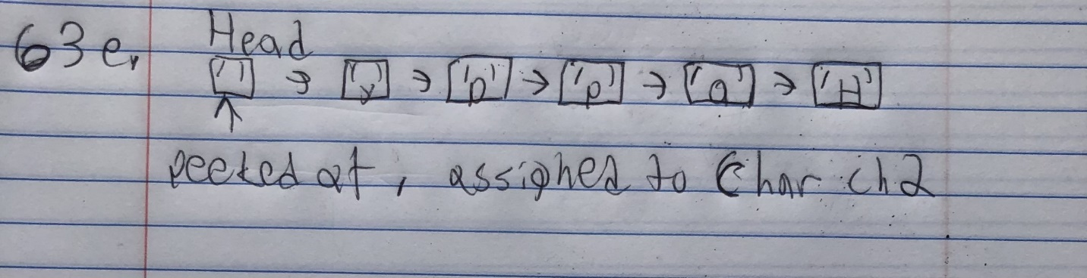

Self-check 4.4 question 1

$$4 7 + 5 * 3- 6 /$$

$$4 7+$$

$$11 5*$$

$$55 3-$$

$$52 6/$$

$$8$$

$$13 2 * 5/6 2 5 * - +$$

$$13 2*$$

$$26 5 /$$

$$5 6 2 5*$$

$$5 6 10-$$

$$5 -4 +$$

$$9$$

$$5 4 / 6 7 – 4 2 / - *$$

$$5 4 /$$

$$1 6 7-$$

$$1-1 4 2 /$$

$$1-1 2-$$

$$1 1*$$

$$1$$